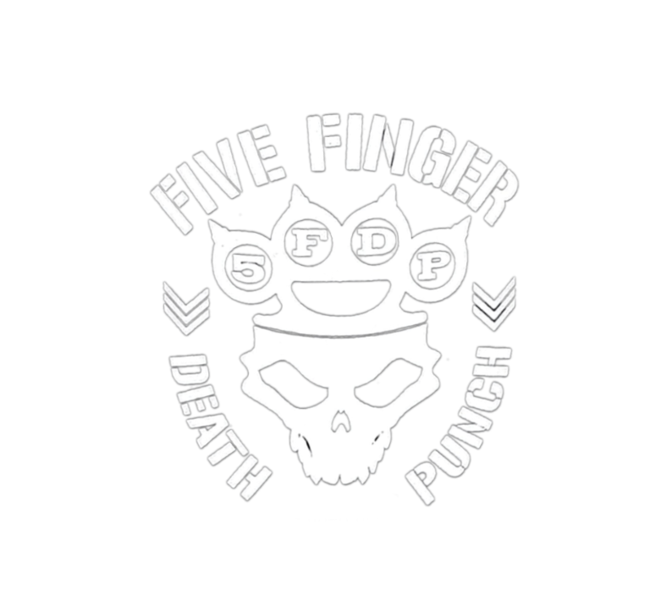
Five Finger Skull Crushers

Stage Plan

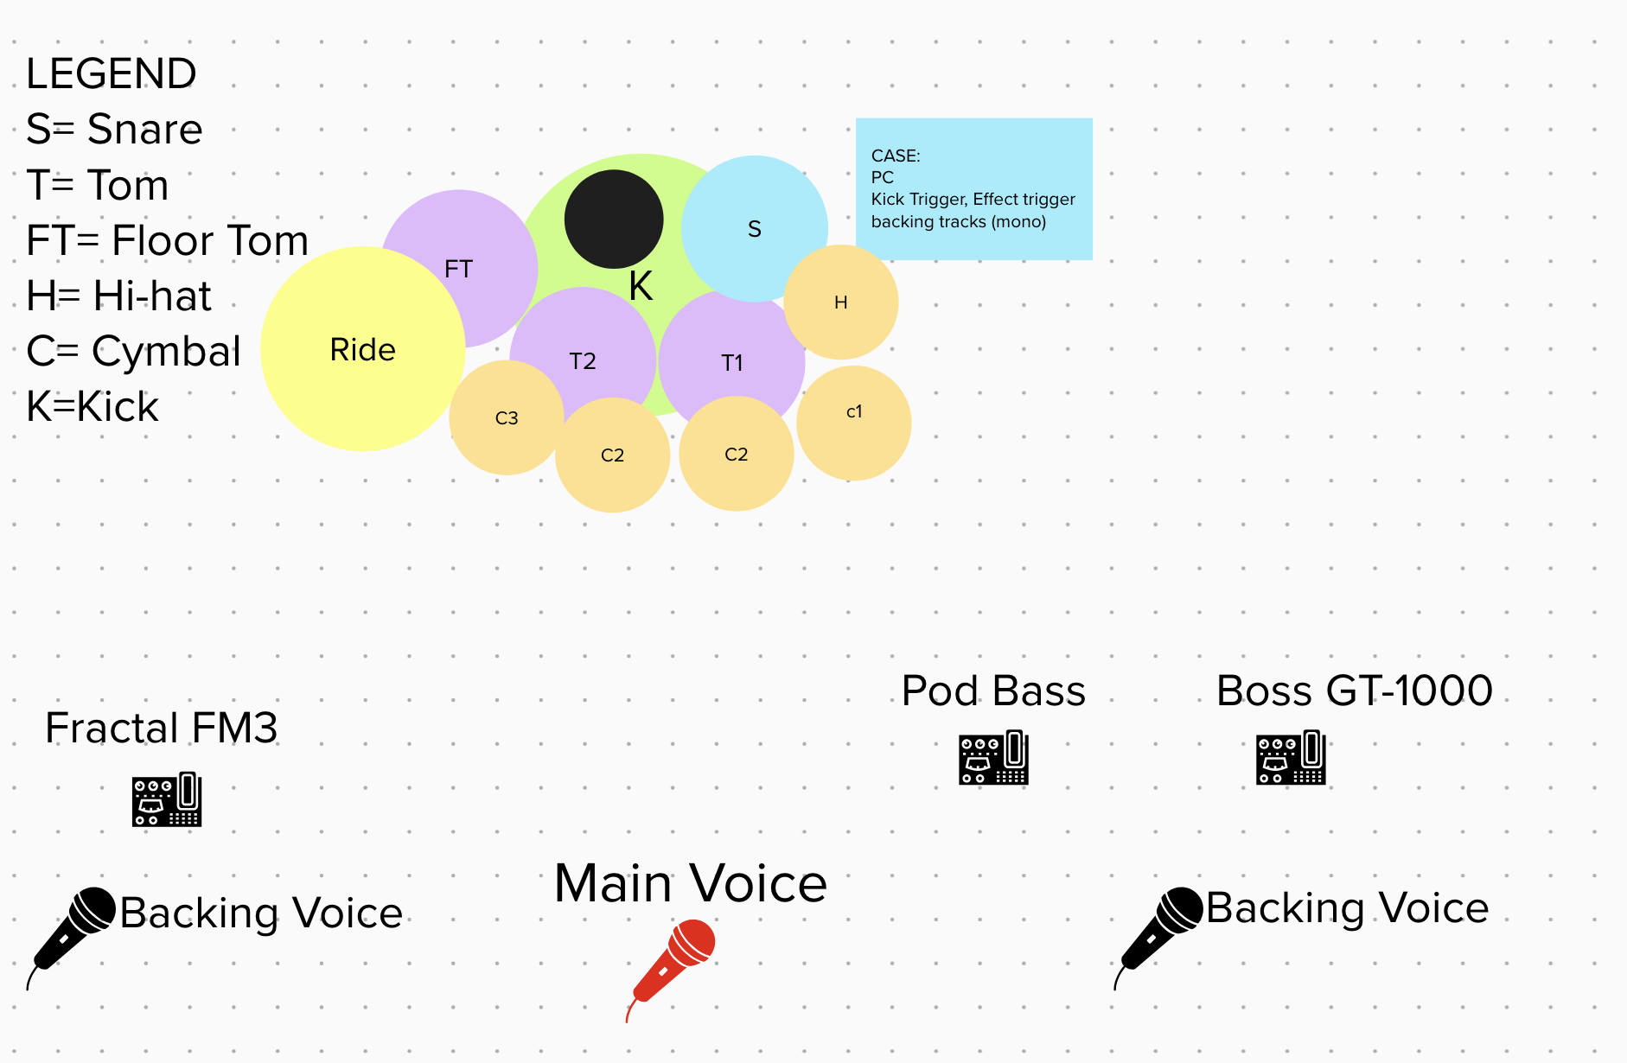

Personal Equipment

Guitar 1
Boss GT-1000
Schecter 7 string

Guitar 2
Fractal FM3
Prs 6 string

Vocal
Wireless Mic T-Bones

Bass
Bass pod pedal board
ESP Bass

Drums
1 Snare 14’
1 Kick drum 22'
1 Kick Trigger
1 Tom 10'
1 Tom 12'
1 Floor tom 16'
1 Hi-hat standard stand
5 Counterweighted boom stands
3 D.I. to send samples from the PC

Required equipment
Vocals
1 Straight stand (main vocals)
2 Cable microphones + tripod mic stand with telescopic boom (backing vocals)

Channel List
Drums : (10/11 Channels)
Kick, snare, 2 toms, 1 floor tom, 1 hi-hat, 1-2 cymbals mics , 1 XLR for samples + 2 XLR cable for Triggers
Guitars1 : (1 Channels) 1 XLR cable
Guitars2 : (1 Channels) 1 XLR cable
Bass : (1 Channels) 1 D.I. (not provided)
Voices :(3 Channels) 1 main vocals, 2 backing vocals

CONTACTS

Booking:
Simone +39 389 253 8647
Stage and Tech:
Edo +39 339 250 8334
Vittorio +39 3393438193
Social Network
Vittorio +39 3393438193/rizzo.vittorio@gmail.com
Marco +39 3334625495/marcopietro.gatto@gmail.com

